 Office Document Creation Checklists

PDFs:
1. Don’t simply scan MS Word or other documents, as heading structures and alt text will not be included. Instead, make sure the Word doc is accessible (previous checklist). Then choose “File” from a Word doc and select “Save as Adobe PDF”.
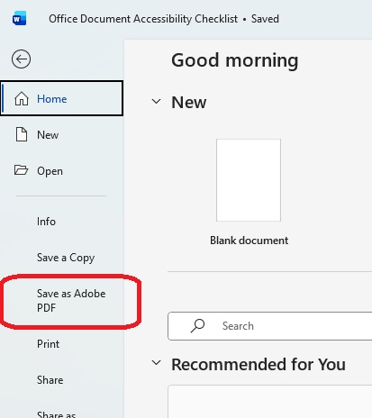
Accessible PDFs - Government Information Center
2. Add alternative text to images:
Use Adobe Acrobat’s “Set Alternate Text” feature by right-clicking images in the Accessibility pane.
Adding alt text in Acrobat
3. Ensure PDFs are searchable:
Run OCR (Optical Character Recognition) on scanned PDFs via Adobe Acrobat’s “Scan & OCR” tool.
Using OCR in Acrobat
Free PAVE PDF Accessibility Checker:
https://pave-pdf.org/pave/index.html#

